Add New Status Reason Attribute

Example is for a CI Record Status Reason

- Using Developer Studio, AST:Attribute Form: Add the new Status Reason attribute(s) in the field called "Status Reason"(1000000150) on form. Make a note of each new Status Reason attribute ID.
- Using Client, SYS:Status Reason Menu Items Form: Add a record.
For CI records, the Form Name is BMC.CORE:BMC_BaseElement. Character Field Value, select the number equivalent of the Status value then type the word for the corresponding numeric value. NOTE: remember that the first Status attribute numeric value is “0” (zero). For the “Selection Code* field, use the new Status Reason attribute ID.
- Clear the server cache and have users clear their browser cache.
- Set a CI with one of the new Status Reason attributes. Check that the field values are reflected on join form.

I added “Lost”, “Stolen”, “Need to Find”, “Damaged”, “Surplus Pending”. This allows our team to use the Status value as appropriate and select a defining Status Reason.

Example

Character Field Value: 0
Status: Ordered
Status Reason: Missing in Shipment
ID: 7010

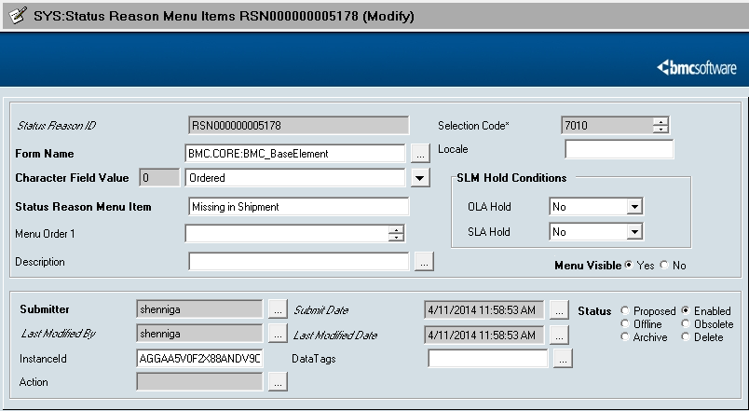
HPD:Help Desk

- For form HPD:Help Desk, add the Attribute to field, Status_Reason_Hidden. Make a note of each new Status Reason attribute ID.
- Add a record to form SYS:Status Reason Menu Items Form.

WOI:Work Order

- For form WOI:WorkOrder, add the attribute to field, 1zD Status Reason. Make a note of each new Status Reason attribute ID.
- Add a record to form SYS:Status Reason Menu Items Form.

