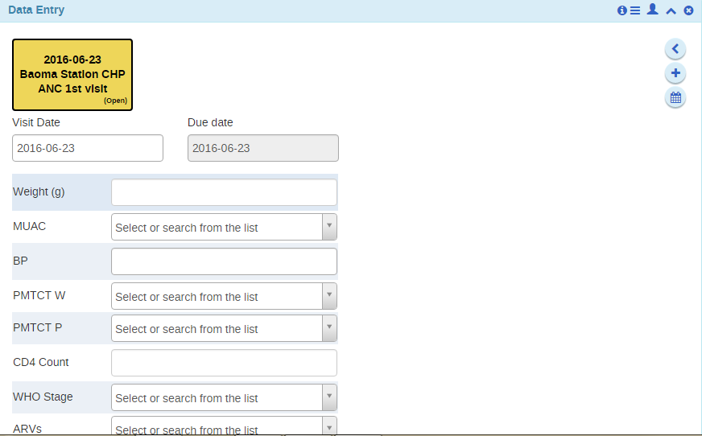
Screen reduces to left most column for default form leaving a space as shown above instead of filling up here based on length of the caption of the text box

