Total Office Solution
A r r o w
Jawed Akhtar 052 3801795
E-mail: jawedakhtar00@yahoo.com

We arrow are please to introduce ourselves, as a supplier and service if Total Office need in..

- Office Equipment’s ( Sales & Service) Free checkup
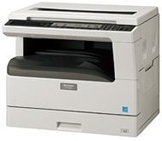Copier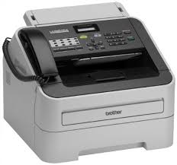Fax 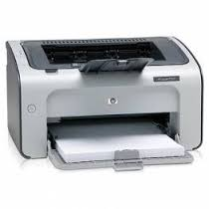Printer
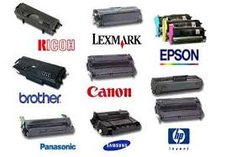Toners & Cartridges
We are providing you all your requirements at your door step in good price.
Awaiting your quick reply.
Thanks,
For Arrow
Jawed 052 380 1795 ( whatsApp 052 62 17567)

