I have three layers problem. The top and side bounds are "neumann", part of top bound has nonzero flux. The bottom bound is “outflow”.
I try to solve problem by Richards and 2p coupled.
Formulation of the problem for Richards is in the attached file.
Problem: the liquid does not flow into the middle layer, the saturation of the upper layer reaches the unit and the problem falls (Fig. 1). Cell coordinates, where task falls, correspond to the upper layer (Fig.2).

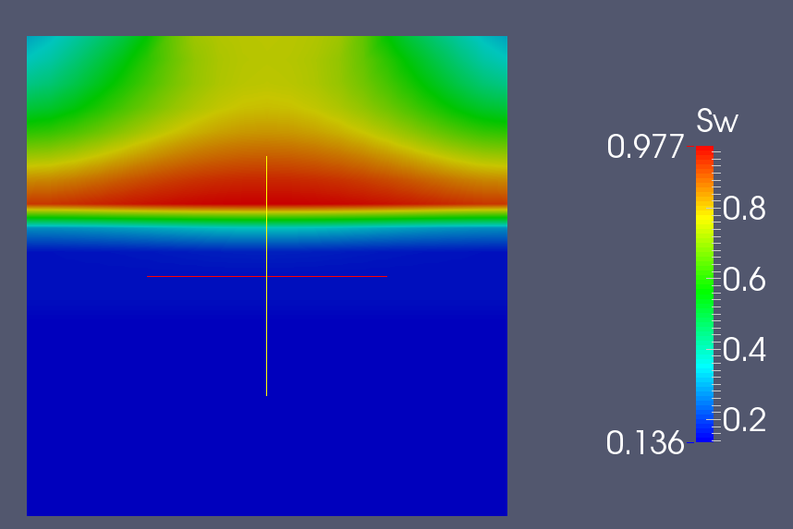
Figure 1.

Figure 2.
Limiting of integration step, limiting of number of Newton iterations, changing of parameter ImpliciteMobilityUpwindWeight couldn’t help to solve the problem.
Coupled method has given a similar result.

