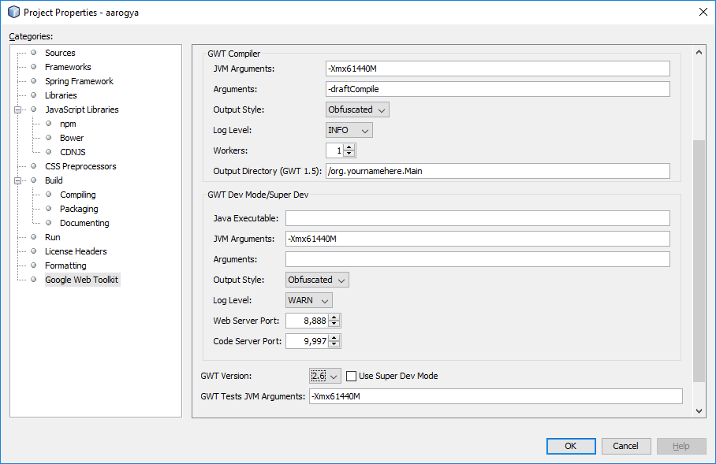

ant -f E:\\users\\vineet\\projects\\J2EE\\otherProjects\\aarogya\\aarogya -Dnb.internal.action.name=rebuild -DforceRedeploy=false -Dbrowser.context=E:\\users\\vineet\\projects\\J2EE\\otherProjects\\aarogya\\aarogya clean dist
Compiling module aarogya.Aarogya
Validating units:
Ignored 10 units with compilation errors in first pass.
Compile with -strict or with -logLevel set to TRACE or DEBUG to see all errors.
Computing all possible rebind results for 'aarogya.master.prescriptionGuiMapping.client.PrescriptionGuiMapping_Dsg.GridDescription_PrpAcs'
Rebinding aarogya.master.prescriptionGuiMapping.client.PrescriptionGuiMapping_Dsg.GridDescription_PrpAcs
Invoking generator com.sencha.gxt.data.rebind.PropertyAccessGenerator
Building method: public abstract com.sencha.gxt.core.client.ValueProvider<aarogya.master.prescriptionGuiMapping.shared.GridDescription_Mdl, java.lang.String> reportNamePrefix()
Running class com.sencha.gxt.data.rebind.ValueProviderCreator
[WARN] Method getReportNamePrefix could not be found
Computing all possible rebind results for 'aarogya.ot.preOperative.client.PreOperative_Dsg.GrdRoutineHistory_PrpAcs'
Rebinding aarogya.ot.preOperative.client.PreOperative_Dsg.GrdRoutineHistory_PrpAcs
Invoking generator com.sencha.gxt.data.rebind.PropertyAccessGenerator
Building method: public abstract com.sencha.gxt.core.client.ValueProvider<aarogya.ot.preOperative.shared.GrdRoutine_Mdl, java.lang.String> isStatus()
Running class com.sencha.gxt.data.rebind.ValueProviderCreator
[WARN] Method getIsStatus could not be found
Computing all possible rebind results for 'aarogya.ot.preAnesthesia.client.PreAnesthesia_Dsg.GrdRoutineHistory_PrpAcs'
Rebinding aarogya.ot.preAnesthesia.client.PreAnesthesia_Dsg.GrdRoutineHistory_PrpAcs
Invoking generator com.sencha.gxt.data.rebind.PropertyAccessGenerator
Building method: public abstract com.sencha.gxt.core.client.ValueProvider<aarogya.ot.preAnesthesia.shared.GrdRoutine_Mdl, java.lang.String> isStatus()
Running class com.sencha.gxt.data.rebind.ValueProviderCreator
[WARN] Method getIsStatus could not be found
Computing all possible rebind results for 'aarogya.ot.anesthesia.client.Anesthesia_Dsg.GrdRoutineHistory_PrpAcs'
Rebinding aarogya.ot.anesthesia.client.Anesthesia_Dsg.GrdRoutineHistory_PrpAcs
Invoking generator com.sencha.gxt.data.rebind.PropertyAccessGenerator
Building method: public abstract com.sencha.gxt.core.client.ValueProvider<aarogya.ot.anesthesia.shared.GrdRoutine_Mdl, java.lang.String> isStatus()
Running class com.sencha.gxt.data.rebind.ValueProviderCreator
[WARN] Method getIsStatus could not be found
Exception in thread "main" java.lang.OutOfMemoryError
at java.io.ByteArrayOutputStream.hugeCapacity(ByteArrayOutputStream.java:123)
at java.io.ByteArrayOutputStream.grow(ByteArrayOutputStream.java:117)
at java.io.ByteArrayOutputStream.ensureCapacity(ByteArrayOutputStream.java:93)
at java.io.ByteArrayOutputStream.write(ByteArrayOutputStream.java:153)
at java.io.ObjectOutputStream$BlockDataOutputStream.drain(ObjectOutputStream.java:1877)
at java.io.ObjectOutputStream$BlockDataOutputStream.setBlockDataMode(ObjectOutputStream.java:1786)
at java.io.ObjectOutputStream.writeObject0(ObjectOutputStream.java:1189)
at java.io.ObjectOutputStream.writeObject(ObjectOutputStream.java:348)
at com.google.gwt.dev.util.Util.writeObjectToStream(Util.java:1193)
at com.google.gwt.dev.util.DiskCache.writeObject(DiskCache.java:227)
at com.google.gwt.dev.jjs.UnifiedAst.<init>(UnifiedAst.java:110)
at com.google.gwt.dev.jjs.JavaToJavaScriptCompiler.precompile(JavaToJavaScriptCompiler.java:769)
at com.google.gwt.dev.jjs.JavaScriptCompiler.precompile(JavaScriptCompiler.java:34)
at com.google.gwt.dev.Precompile.precompile(Precompile.java:271)
at com.google.gwt.dev.Precompile.precompile(Precompile.java:223)
at com.google.gwt.dev.Precompile.precompile(Precompile.java:139)
at com.google.gwt.dev.Compiler.run(Compiler.java:167)
at com.google.gwt.dev.Compiler.run(Compiler.java:132)
at com.google.gwt.dev.Compiler$1.run(Compiler.java:99)
at com.google.gwt.dev.CompileTaskRunner.doRun(CompileTaskRunner.java:55)
at com.google.gwt.dev.CompileTaskRunner.runWithAppropriateLogger(CompileTaskRunner.java:50)
at com.google.gwt.dev.Compiler.main(Compiler.java:106)

