Estimate sample size based on retrospective records
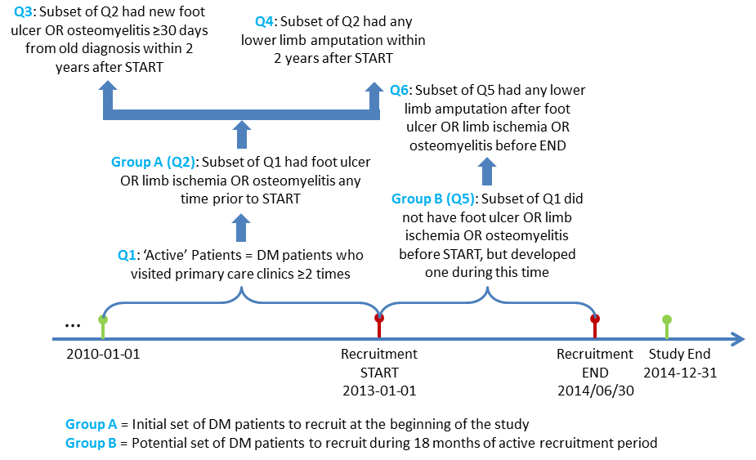
Following queries need to be run for three populations:
- ALL = NO race specification
- AA = African American
- CA = Caucasian
***All patients must be ALIVE before the Study START 2013-01-01

Q1: # of diabetic patients who visited primary care clinics at least 2 times between 2010-01-01 and 2012-12-31 & must be alive before 2013-01-01
Queries:
- LEA-Q1-ALL
- LEA-Q1-AA
- LEA-Q1-CA

Q2: Subset of Q1 patients who developed foot ulcer OR limb ischemia OR osteomyelitis any time before 2013-01-01
Queries: Please substitute with patient set generated from Q1
- LEA-Q2-ALL
- LEA-Q2-AA
- LEA-Q2-CA

Q3: Subset of Q2 patients who developed new foot ulcer OR osteomyelitis ≥30 days later after the previous foot ulcer OR limb ischemia OR osteomyelitis within 2 years after START, i.e., between 2013-01-01 and 2014-12-31
Queries: Please substitute with patient set generated from Q2
- LEA-Q3-ALL
- LEA-Q3-AA
- LEA-Q3-CA

Q4: Subset of Q2 patients who developed any lower limb amputation within 2 years after START, i.e., between 2013-01-01 and 2014-12-31
Queries: Please substitute with patient set generated from Q2
- LEA-Q4-ALL
- LEA-Q4-AA
- LEA-Q4-CA

Q5: Subset of Q1 patients who did not have foot ulcer OR limb ischemia OR osteomyelitis prior to 2013-01-01, but developed one during the study between 2013-01-01 and 2014-06-30
Queries: Please substitute with patient set generated from Q1
- LEA-Q5-ALL
- LEA-Q5-AA
- LEA-Q5-CA

Q6: Subset of Q5 patients who developed any lower limb amputation after their foot ulcer OR limb ischemia OR osteomyelitis diagnoses between 2013-01-01 and 2014-12-31
Queries: Please substitute with patient set generated from Q5
- LEA-Q6-ALL
- LEA-Q6-AA
- LEA-Q6-CA

