The European Division and the Hebrew Language Table, Library of Congress,
present a lecture and film by Katalin Cserépfalvi-Galligan:

Albert Goering: A Good Man

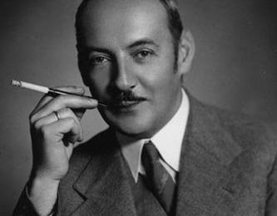

This is the story of a remarkable man, who saved many Jewish lives during World War II in Hungary and other countries. Even more astounding is that Albert was the younger brother of Hermann Goering, the notorious Nazi military leader during the War.

Dr. Cserépfalvi-Galligan will also show an excerpt from a documentary made by Janos Tári about the speaker and her autobiographical book Mimimikoko Illegális élete (Mimikoko Underground; the story of the deportation of Hungary’s Jews in 1944 as seen through the eyes of a little girl) and Albert Goering. This video is part of the documentary collection Rescuers and Recued, which will premiere in Budapest on December 1.

European Division Conference Room
Jefferson Building, LJ-250
Wednesday, November 19, 2014
12:00 noon – 1:00pm

For Information:
Contact Gail Shirazi, 707-9897 / email gshi@loc.gov or
Kenneth Nyirady, 707-8493 / email knyi@loc.gov

Request ADA accommodations five business days in advance
at (202) 707-6362 (Voice/TTY) or email ada@loc.gov

