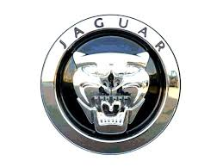

Congratulation: Dear Email Winner,

This Email is to inform you that your email address has just won you

$800, 000.00 dollars and jaguar car in the ongoing Jaguar automobile

Anniversary promotion draws held today in India 17th July, 2013.

Contact the fiduciary agent with contact information stated below:

Name in full:

Address:

Occupation:

Country:

State:

Tel/fax:

Marital Status:

Contact Person.

Mr. Diamond Fortune,

Kindly Contact E-mail: jaguarmotors@outlook.com

Congratulation Once Again!!!

