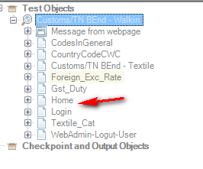

The above shows the shared resipotory.
The following are the steps to the query:
- I have 2 scripts (Script 1 and Script2) that uses the ‘Home’ object as coded in both scripts and saved.
- Next re-open script 1 and renamed the ‘ Home’ object to be called ‘Home1’ in the shared resipotory.

- Script1 , will auto change to as ‘Home1’ as below
browser("Customs/TN BEnd - Walkin").Page("Home1").Link("Country Codes (CWC State").Click
- I saved this Script1.
- I opened Script2, however the code is showing ‘Home’ in Script2, thought that it should be ‘Home1’ as well, but it is not, is this the correct behaviour ? I have to manually change ‘Home’ to ‘Home1’ ?
browser("Customs/TN BEnd - Walkin").Page("Home").Link("Country Codes (CWC State").Click

My query will be that if I have 10 scripts using ‘Home1’ name ,I will need to open each script to update the code to ‘Home1’ from ‘Home’ (code), system will not auto update the 9 other scripts ?

Please advise me, thank you.

