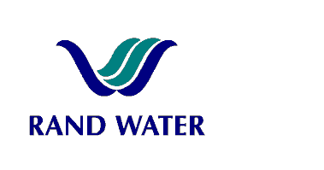
Internal and External applications are invited from suitably qualified persons to fill the following vacancy in the Operations Divisions, Office of the Executive Manager at Zwartkopjes Pumping Station.

OFFICE ASSISTANT

(H - Band)

OVERALL RESPONSIBILITY
- Provides an hygienic refreshment services to all personnel in the Admin Building – Executive Manager’s Office, Assist the Senior Secretary with allocated routine offices duties and maintains all offices of the Executive Manager’s Office.

PRIMARY DUTIES

- Accurate filing for Executive Manager’s Office
- Offices cleaned as per agreement.
- Meeting/function venues are prepared before events start and tidied after events are completed
- Delegated administrative functions are conducted as required (e.g. vehicle trip-sheet admin, capturing data, photocopying, distributing post, etc.)
- Refreshments prepared for visitors

JOB REQUIREMENTS

- Grade 12 with 1 year relevant administrative experience
- 1 Year experience as a messenger in a typical admin environment
- Must be literate
- Computer literate

COMPETENCY PROFILE
KNOWLEDGE | SKILLS | BEHAVIOUR
- Office Administration  - Cleaning  - Safety | - Communication skills (Verbal & Written) | - Team Player  - Performance orientated  - Self-motivated.  - Customer service orientated.  - Friendly/ Patient  - Safety conscious  - Good interpersonal skills  - Confidentiality beyond approach
In evaluating prospective applicants and making the final selection, preference will be given to FEMALES and / or PEOPLE WITH DISABILITIES to give effect to Rand Water’s Employment Equity Objectives.
Should you not receive correspondence from Rand Water within 30 days from closing date, please accept that your application has been unsuccessful.
Applications must be submitted to Human Resources Department, Zwartkopjes.
Fax: 011 - 900 4361
E-mail: mmaaroha@randwater.co.za

CLOSING DATE: 18 July 2011

