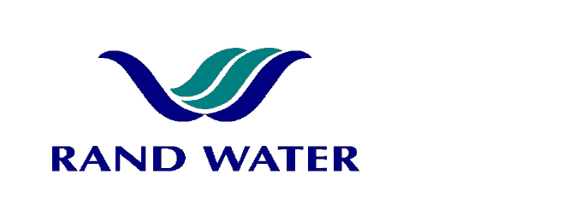

Internal and External applications are invited from suitably qualified persons to fill the following vacancy in the Operations Division at Zwartkopjes Pumping Station.

Process Control Assistant /General – (Shift Work)
(HAYBAND – I)

OVERALL RESPONSIBILITY
- To maintain good housekeeping of engine rooms control rooms, battery rooms, toilets, switchgear room floors. To report unsafe act and/or working conditions as any abnormalities to his or her Shift Supervisor

PRIMARY DUTIES
- Cleaning up in and around the engine room, electric pumps, floors, control rooms and basements
- Fill sample bottles as required by laboratory and the Senior Process Controller
- Assist Senior Process Controller with loading and unloading of chlorine cylinders
- Assist Senior Process Controller with off loading of ammonia from the tanker
- Loading and unloading of water sample bottles crates in and out of shift change vehicle

JOB REQUIREMENTS

ABET Level 3 / Standard 8 with Maths and Science

Related cleaning experience will serve as an advantage

Knowledge of water purification exposure will serve as an advantage

Blue Drop requirements: Water Treatment Learnership will serve as an advantage.

COMPETENCY PROFILE

KNOWLEDGE | SKILLS | BEHAVIOUR
- Basic Cleaning Knowledge  - Cleaning materials and chemical used  - Safe working procedures  - Occupational Safety & Hygiene | - Communication Skills  - Numeracy | - Self discipline  - Punctuality  - Loyalty  - Initiated driven

In evaluating prospective applicants and making the final selection, preference will be given to Females and/or People with Disability to give effect to Rand Water’s Employment Equity Objectives.
Should you not receive correspondence from Rand Water within 30 days from the closing date, please accept that your application has been unsuccessful.

APPLICATIONS MUST BE SUBMITTED TO HUMAN RESOURCES – ZWARTKOPJES.

.Fax Number: 011 - 900 4361
E-mail: mmaaroha@randwater.co.za

CLOSING DATE: 21 September 2011

