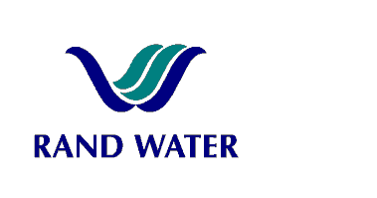
Internal and External applications are invited from suitably qualified persons to fill the following vacancy in the Operations Department, at Zwartkopjes Pumping Station.

OPERATIONS TRAINING OFFICER

(M - Band)

OVERALL RESPONSIBILITY
- Responsible for the technical training and coordination of all Operational and Maintenance staff in accordance with the workplace skills plan. Responsible for the writing, approval, updating and distribution of operating procedure for all plant and equipment in the Operations Sections.

PRIMARY DUTIES

- Implement Operations Career development programmers on site
- Scan environment for new training developments
- Engage in ongoing site operations and organizational analysis to derive comprehensive operations training needs assessment
- Plan and implement Operations Training plans and procedures
- Develop, coordinate and present operating procedures
- Develop, coordinate and present operations training programmes on site
- Indentify and implement Operations Training and procedures projects at site level
- Performance and control management

JOB REQUIREMENTS

- NTD or National Diploma/NQF Level 5
- Code 8 Drivers Licence
- 5 years experience in water purification
- Computer literate

COMPETENCY PROFILE
KNOWLEDGE | SKILLS | BEHAVIOUR
- Knowledge of OHS Act and its application  - Operation of H.V. electrical equipment, dosing pumps and large pumping units  - Knowledge and application of ISO 14000 and ISO 9001 | - Good leadership and Sound labour relations skills  - Communication Skill (Verbal and Written)  - Administration skills  - Conflict resolution  - Computer literacy | - Problem Solving  - Conflict resolution  - Mentoring and application of ISO 14000 and ISO 9001  - Good interpersonal skills  - Confidentiality beyond approach
In evaluating prospective applicants and making the final selection, preference will be given to FEMALES and / or PEOPLE WITH DISABILITIES to give effect to Rand Water’s Employment Equity Objectives.
Should you not receive correspondence from Rand Water within 30 days from closing date, please accept that your application has been unsuccessful.
Applications must be submitted to Human Resources Department, Zwartkopjes.
Fax: 0865552760
E-mail: mmaaroha@randwater.co.za

CLOSING DATE: 22 February 2012

