MEMO 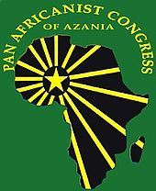
TO : All PAC Members and Component Structures
( APLAMVA, PAWO, PASMA and PAYCO)
FROM : Provincial Secretary of the PAC Gauteng Province
RE : PAC Provincial Policy Dialogue
DATE : 19 March 2012

The Pan Africanist Congress of Azania ( Gauteng Province) will be hosting a Provincial Policy Dialogue. This dialogue is aimed at reviewing the relevance and effectiveness of the current internal party policies, to reflect and propose both constitutional and policy amendments which shall be tabled at the National Policy Conference of the PAC.
The Provincial Policy Dialogue will be held as follows:
Date: 24 March 2012
Time: 09:00-17:00
Venue: Braamfontien Civic Centre (Johannesburg)
All PAC members and Gauteng based structures ( Branches and Regions, APLAMVA, PAWO, PAYCO and PASO) are invited to participate on this important organizational gathering and deliberate on strategic policy issues, and influence policy direction with in the PAC.
Fore more information regarding the Dialogue kindly liaise with the PAC Provincial Spokesperson: Sello Tladi at +27-83-859-1654 / E-mail to rmsello@gmail.com or the PAC Provincial Secretary: Tommy ka-Ntando at +27-82-930-8735/ tommykantando@yahoo.co.uk

