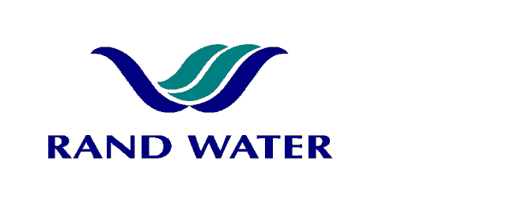

Internal and External applications are invited from suitably qualified persons to fill the following vacancies in the Operations Division at Zuikerbosch Water Treatment Plant, Operations.

PROCESS CONTROL ASSISTANT – WATER PURIFICTION x 2
(I Hay band)

OVERALL RESPONSIBILITY

To render assistance in all purification process plants with cleaning and maintenance tasks, as well as during plant and pipeline shutdowns.

PRIMARY DUTIES

- Desludging of sedimentation systems
- Cleaning of treatment plants, chemical pipe work, chemical tanks and canal screens.
- Sterization and maintenance of filters when required.
- Isolation and cleaning of sedimentation tanks.
- General maintenance tasks.

JOB REQUIREMENTS

- Grade 10 or NQF Level 1
- Previous plant experience preferable
- Physically fit and strong

COMPETENCY PROFILE

KNOWLEDGE | SKILLS | BEHAVIOUR
- Basic understanding of water treatment process.  - Basic rigging.  - Basic understanding of valves, pressure and flow principles.  - Safety working procedures. | - Good communication skills (verbal)  - Good housekeeping skills  - Able to work under pressure. | - General safety conscious.  - Good working relations  - Co-operation  - Willing to work overtime.

In making the final selection, consideration will be given to achieving
Rand Water’s Employment Equity Objectives.

Should you not receive correspondence from Rand Water within 30 days from the closing date, please accept that your application has been unsuccessful.

APPLICATIONS MUST BE SUBMITTED TO HUMAN RESOURCES ZUIKERBOSCH

E-MAIL: Sherbst@randwater.co.za
Fax 086-536-3950
CLOSING DATE: 10 December 2012
NOTICE NUMBER: ZB 34-2012

