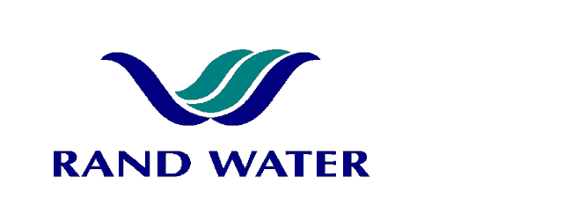
Internal and External applications are invited from suitably qualified persons to fill the following vacancy in the Maintenance Core Department, Operations Division at Zuikerbosch Water Treatment Plant.

INSTRUMENT ASSISTANT
(M Hay band)

OVERALL RESPONSIBILITY
The instrument Assistant (Senior Instrument Mechanician) will be responsible for the maintenance of instrumentation and performing of PLC/SCADA functions at an intermediate level as in designated areas in order to meet the operational demands.

PRIMARY DUTIES
- Receiving job cards for repairs and attending to breakdowns and faults.
- Diagnosing faults in loops etc. and reassembling and testing equipment.
- Carrying out routine inspections and maintenance of equipment in accordance with work schedule.
- Carrying out new installation and commissioning in accordance with wire diagrams.
- To ensure correct readings of metering equipment.
- General maintenance and installation of pneumatic and electronic control equipment.
- Working with an extensive range of pressures, level transmitters, density and temperature instruments.
- Responsible for continuous improvement tasks in responsible areas.
- Responsible for the development of instrument mechanics and apprentices.
- Responsible for identifying critical spares stock levels within responsible area.
- Be able to act in the capacity of a foreperson during his/her absence.
- Maintain reliability and availability targets within specific sections.
- Must be able to analyze and scrutinize the quality of information given to management

JOB REQUIREMENTS
- A preferred candidate should have a national diploma though a Minimum qualification of N5 or equivalent coupled with a recognized apprenticeship in instrumentation will be considered.
- 5+ years post apprenticeship experience.
- A valid Code B driver’s license and ability to pass Rand Water’s K53 test.

COMPETENCY PROFILE
KNOWLEDGE | SKILLS | BEHAVIOUR
- Scada/telemetry system  - PLC’s  - Safety system  - Industrial instruments | - Proven ability to maintain instrumentation plant and equipment  - Analytical Skills  - Communication  - Fault finding | - Performance driven  - Customer service orientation  - Team player  - Self motivated  - Safety conscious
Applications must be submitted to the Talent Management Officer, Human Resources, Zuikerbosch
Sherbst@randwater.co.za
Fax 086-536-3950

CLOSING DATE: 4 April 2013 NOTICE NO: Zb 14-2013

In making the final selection, consideration will be given to achieve Rand Water’s Employment Equity objectives.

Should you not receive correspondence from Rand Water within 30 days from the closing date, please accept that your application has been unsuccessful.

