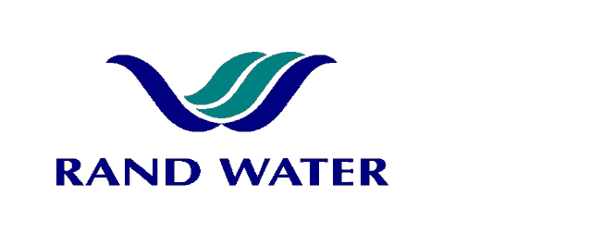

Internal and External applications are invited from suitably qualified persons to fill the following vacancy in the Operations Division at Zuikerbosch Water Treatment Plant, Maintenance Core Department.

ELECTRICIAN
(Dry trade)

OVERALL RESPONSIBILITY
To assume responsibility for the installation, maintenance, troubleshooting and repair of Plant Equipments to ensure that Reliability and Availability targets are met.

PRIMARY DUTIES
- To carry out preventative maintenance and fault finding on HT and LT control systems of electrical pumps and associated equipment.
- Investigate and repair failures.
- Perform standby duties and work overtime if and when required.
- Complete work orders as required.
- Maintain and update Electrical drawings.

JOB REQUIREMENTS
- Minimum N3 coupled with a recognized trade test in the Electrical field.
- 5 years post apprenticeship experience in the maintenance environment.
- High voltage experience including experience in operating high voltage equipment and the ability to obtain the O.R.H.V.S certificate as per Eskom standard
- Code B Driver’s license and the ability to pass RW`s driving test
- Knowledge of PLC’s and possession of a wireman’s licence will be an added advantage
- Experience in setting and repair of actuators will serve as an advantage

COMPETENCY PROFILE

KNOWLEDGE | SKILLS | BEHAVIOUR
- Sound knowledge on the following:  - Oil- and vacuum circuit breakers  - AC & DC drives  - Soft starters and conveyor systems  - PLC's  - Occupational Health and Safety Act  - Fault finding | - Ability to solve problems.  - Initiative  - Team player  - Good communication skills  - Analytical thinking  - Ability to Read and understand electrical schematic drawings | - Attention to detail/quality  - Self-motivated  - Customer service oriented  - Must have the willingness to accept responsibility  - Must be able to work independently and under pressure

In making the final selection, consideration will be given to achieving
Rand Water’s Employment Equity Objectives.

Should you not receive correspondence from Rand Water within 30 days from the closing date, please accept that your application has been unsuccessful.

APPLICATIONS MUST BE SUBMITTED TO HUMAN RESOURCES ZUIKERBOSCH

E-MAIL: Sherbst@randwater.co.za Fax 086-536-3950
CLOSING DATE: 25 June 2013 NOTICE NUMBER: ZB 25-2013

