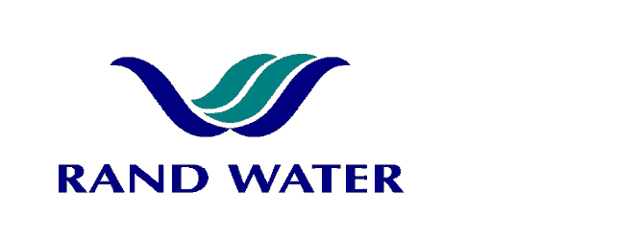

Internal and External applications are invited from suitably qualified persons to fill the following vacancy in the Operations Division at Zwartkopjes

Senior Process Controller – Pumping
(A1 – BAND) (Shift Work)

OVERALL RESPONSIBILITY
- Report to the Senior Process Supervisor on shift, and operate and supervise the Electrical plant and equipment.

PRIMARY DUTIES

- Operation of disinfection Plant (Chlorine and Ammonia injection system).
- Monitoring of Water Quality by ensuring compliance with the Production Water Quality Guidelines.
- Safety & Housekeeping of Electrical Pumping Plant.
- Supervisory of Process Controller Assistant and plant equipment.
- Communicate with the Senior Process Supervisor efficiently and effectively on water quality matters and pumping
- Manage and control of shifts.
- Energy Management

JOB REQUIREMENTS
- Matric / Grade 12 / NTC 3 with Maths and Science
- 5 Years plant experience for Controller
- 2 Years experience for Senior Process Controller
- Electrical switching experience desirable
- Analytical skills to do fault finding and problem solving
- A valid code 08 Driver’s Licence as well as the ability to pass Rand Water K53 Test will serve as an advantage
- Computer literacy .Senior Process Controller must be able to manipulate information on computer
- Blue Drop Requirements: Ability to be Accepted as a Class1 operator

COMPETENCY PROFILE

KNOWLEDGE | SKILLS | BEHAVIOUR
- Basic knowledge and application of ISO 14000 and ISO 9001  - Basic Chemistry  - Scientific Knowledge  - Basic knowledge of OHS Act and its Application | - Communication Skills (Verbal and Written)  - Analytical Skills to do fault finding and problem solving  - Operation of H.V. and LV electrical equipment and large units  - Administrative Skills | - Safety consciousness whilst ensuring plant reliability.  - Customer orientation.  - Self discipline  - Punctuality  - Speed

In evaluating prospective applicants and making the final selection, preference will be given to Females and/or People with Disability to give effect to Rand Water’s Employment Equity Objectives.
Should you not receive correspondence from Rand Water within 30 days from the closing date, please accept that your application has been unsuccessful.

APPLICATIONS MUST BE SUBMITTED TO HUMAN RESOURCES – ZWARTKOPJES.
Fax Number: Fax: 0865552760
E-mail: zk recruit@randwater.co.za

CLOSING DATE: 02 July 2013

