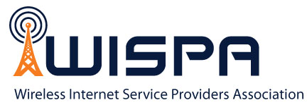

FOR IMMEDIATE RELEASE
December 8, 2014

WISPA Holds Advocacy Week In Washington, D.C.
Organization meets with policy leaders to discuss rulemaking initiatives

Ossian, IN (December 8, 2014) – Representatives of the Wireless Internet Service Providers Association (WISPA), a membership organization that promotes the development, advancement and unity of the fixed wireless Internet service provider industry, met with Congressional and FCC leaders in Washington, D.C. last week to discuss regulations and initiatives that affect the fixed wireless broadband industry and the three million customers that it serves.

During the four-day meetings, which were held December 1-4, 2014, the delegation met with Congressional representatives and FCC Commissioners to discuss the adverse impact that new net neutrality regulations would have on small businesses and the need to modernize the Communications Act.

“The fixed wireless broadband industry is composed of small businesses that provide Internet to unserved and underserved areas in the United States. Many current and proposed regulations, particularly if authorized by Title II of the Communications Act, will will lead to uncertainty and increased costs for those residents and small businesses that are least able to afford it,” said Elizabeth Bowles, WISPA’s Legislative Committee Chair. “The purpose of these meetings was to encourage policy makers to continue with the ‘light-touch’ regulation that has worked in the past and to ensure that any new regulations are tailored to protect these small businesses and their customers.”
About WISPA
WISPA (Wireless Internet Service Provider Association) is a membership-driven trade association that promotes the development, advancement and unity of the fixed Wireless Internet Service Provider industry. WISPA has over 800 members that support WISPA’s advocacy, education and other collaborative industry initiatives. For more information, visit www.wispa.org.

###

FCC Inquiries:
Alex Phillips
alexp@highspeedlink.net
Tel: 540.908.3993

Legislative Inquiries:
Elizabeth Bowles
ebowles@aristotle.net
Tel: 501.374.4638

Media Inquiries:
Suzanne Urash
CRE8 Group, Inc.
suzanne@cre8groupinc.com
Tel: 813.649.8504

