Dears Colleagues,

I am a beginner on using the SUMO software. I have to model a roundabout in a project situation. With three variants of roundabout rearrangement.

The first variant consists in adding four links in a right-hand turn to the four corners of the gyratory.

I work in netedit.

I am asking you to help me and to tell me how to create a node in a current section of the OSM so that we can make the junction between the end of the new link turning right and the current section of the OSM network so that the traffic can take the new link turning right.
Liaison de Tourne à droite
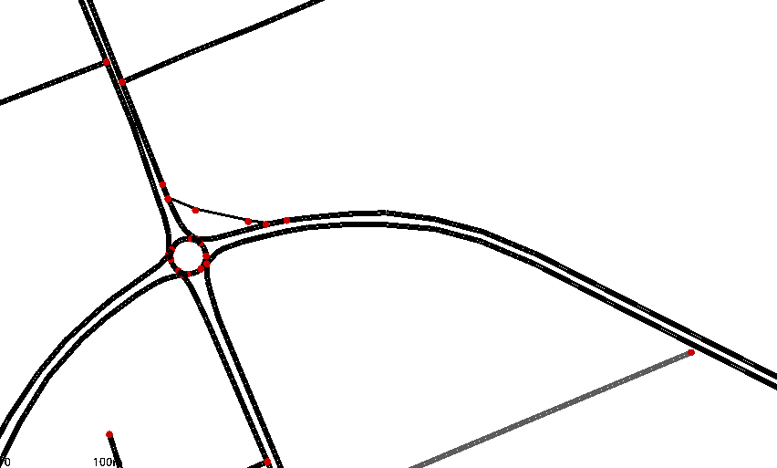
Section courante OSM
Point de jonction

