HP 5061 mini tube retrofit into 5071A part 2!
A few years ago I detailed how to install a ”mini” tube from the 5061A/B into a 5071A.
http://leapsecond.com/corby/HP-5071A-with-5061A-4.docx
It was limited to trying EEPROMS from different tubes to get it to work.
Well here is some more data about modifying the EEPROM for more flexability!
Here is a typical 2nd line from a standard tube EEPROM which contains the parameters of interest.
NOTE: This is the first of 4 identical lines. You need to modify all 4 lines!
000010 00 03 FA 00 00 05 FA 00 00 03 65 00 00 2A E7
HW EM OVEN MS
1.018V 1530V 871 Ohm 10.895V
I've found that by manipulating the bytes in the line to preserve the sum that the unit will usually accept the changes, power up normally, and complete a successful warmup. Not every said change works and I'll explain in the examples.
HW is the Hot Wire ionizer filament voltage and its value is not critical. For 5061 "mini" tubes you want close to 1.00V. Anywhere in the range of .95V to 1.05V will work fine.
EM is the Electron Multiplier voltage and its value is also not critical as the unit dynamically adjusts it. The value in the EEPROM sets the initial EM voltage but during the warmup the instrument changes it as required.
OVEN is the thermistor value that the oven will regulate at to establish the correct oven temperature. This parameter needs to be close to the value required. The mini tubes have thermocouple leads that you can clip onto to measure the actual oven temperature.
MS is the Mass Spectrometer voltage and sets MS voltage to that required by the tube. This parameter also needs to be close to the correct value.
So let us say your EEPROM values are as shown and you need to modify them for a standard performance 5061 "mini" tube.
The tube is marked 105.0 degrees C and 608 Ohms and the measured MS voltage in the 5061 chassis was 10.835 V, which is close enough without changing the MS field value.
The tube did power up OK with the values shown and actually exceeds the stability specs however the temperature is a bit low. 91.1 degrees as the oven parameter was set to 871 Ohms.
BLUE plot in AD chart.

Here is a another 2nd line from another standard tubes EEPROM
000010 00 03 D7 00 00 07 BA 00 00 02 55 00 00 30 8F
HW EM OVEN MS
.983V 1978V 597 Ohm 12.431V
The tube powers up normally and again easily beat the stability specs. This time very close to the 105.0 degree marked on the tube, just a tiny bit hotter. RED plot in the AD chart
I then changed the EM AND the OVEN field to 07B0 and 025F giving 1968V and 607 Ohms, and the MS field to 2A95 giving 10.901V. Bringing the OVEN and MS to nominal.
The tube performed as expected, beating the specs.
GREEN plot in AD chart.
The following explains how values must be changed so that the check work of the EEPROM still works properly!
The sum of the bytes in the modified field (or combined fields) must stay the same as the original sum!
For example an OVEN change from 0365 to 0167 (-2 first word, +2 last word) works where a change from 0365 to 0266 (-1 first word, +1 last word) does not work. BTW the change to 167 resulted in a 131 degree oven temperature effectively making the tube a high performance tube!
Also since the EM is adjusted during warmup you can make changes in one word to allow changes in another field’s word.
For instance in the example:
“I then changed the EM AND the OVEN field to 07B0 and 025F giving 1968V and 607 Ohms.”
Changing the EM from 07BA to 07B0 (a change of -10 in only the second word) and the oven from 0255 to 025f (a change of +10 in only the 2nd word.)
Then the change of the MS from 308F to 2A95 (30 minus 6, and 8F plus 6)
I was able to make numerous changes by sticking to even amounts. I think parity might be involved somehow?
Without figuring out how the check word is computed this will allow changes to an existing EEPROM to get a unit operational.
Have Fun!
Corby

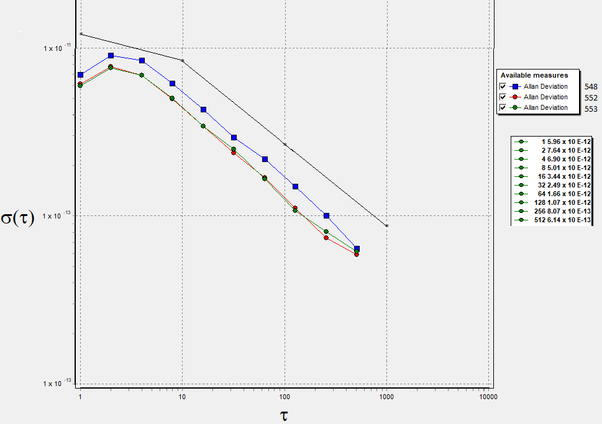
The black line is the HP 5071A standard tube spec.

