Allow Access to a VMware Virtual Machine(NAT) From Another Computer
If you are running a virtual machine on your computer, you may want to access that virtual machine from another computer. Let’s use an example: Say you have an Ubuntu virtual machine with Apache running on port 80, and you want to show other people on your network to access the website you are hosting.
We’re going to assume that the virtual machine is using NAT, and has been assigned an IP address of 192.168.23.128.
First open the Manage Virtual Networks start menu item:
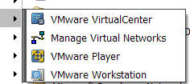
Click on the NAT tab, and then click on Edit. You will see the NAT Settings dialog:
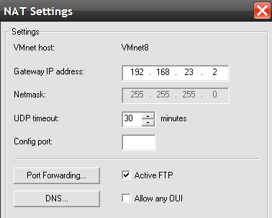
Click the Port Forwarding button, and you will see this dialog:
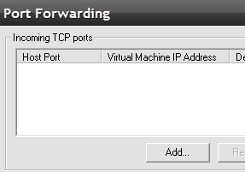
Now we are finally on a screen we can actually use. We’re going to use port 8080 on the host machine. We enter the ip address for the ubuntu virtual machine, and port 80. These ports could be any ports.
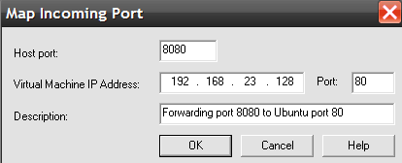
We should be able to test this out by going to http://localhost:8080 on our host pc. We can give out the url to our host machine by replacing localhost with the host computer IP address.

