Here is how your equations render in my system:
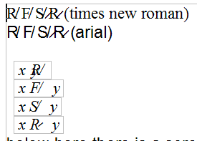
Here is a sample made by my self:

Here is how the *same* equation renders in my system with several zoom options:
100%:
150%:
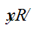
200%:
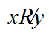
275%:


