In Branchless complexity, each layer uses exactly two connection points, so no color mixing is possible and each completed path will lead from a single primary source to an output. Also, at most two layers are used. 3-Max complexity allows each layer to use either two or three of the connection points, but still uses at most two layers. This level of complexity lets you combine two input colors into a composite output color. You can then use this composite to mix other colors. 4-Max allows up to four connection points per layer and up to three layers, and enables even more possibilities for color mixing. With Dense complexity, there is no specific restriction on the number of connection points a layer may use, and the piece may use all four layers; any given piece might or might not use all the connection points. In Full Rotation mode, and for the initial pattern in Design mode, Solid complexity means that all connection points of all pieces are used; in other game modes, it is effectively the same as Dense complexity.
The higher the complexity in Jigsaw mode, the more pieces can potentially contribute to the path for a particular ink color; in the other modes, the more color mixing occurs and the more likely you are to accidentally create undesirable or invalid flows. Of course, in Design mode you are not bound by any restrictions on complexity; the complexity setting affects only how the initial grid is set up.
If you are just getting started with playing PipeInk, you might want to try each mode in Branchless complexity to become familiar with color flow and controls before dealing with color mixing using a higher complexity.

Game Play
All the game modes share many characteristics and some play controls. Pipes have the same shapes, and ink colors mix the same way when pipes join (except that in Jigsaw mode, this occurs before the game starts and the ink color then remains static).
Five different primary source colors are provided. Cyan (C), magenta (M), yellow (Y), and black (K) each have sources at the top (three each for cyan and black, two each for magenta and yellow). White (W) has five sources on each side. These source colors can be mixed, by connecting pipes, to create the additional colors shown here.
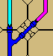 | C + M  blue | 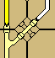 | Y + W  light yellow
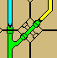 | C + Y  green | 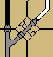 | K + W  gray
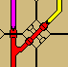 | M + Y  red | 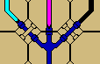 | C + M + K  dark blue
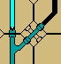 | C + K  dark cyan | 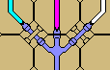 | C + M + W  light blue
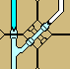 | C + W  light cyan | 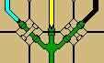 | C + Y + K  dark green
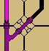 | M + K  dark magenta | 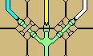 | C + Y + W  light green
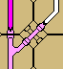 | M + W  light magenta | 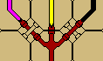 | M + Y + K  dark red
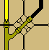 | Y + K  dark yellow | 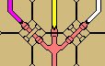 | M + Y + W  light red

All other color mixes are invalid, and will appear as a dark brown in white pipes in the affected pieces.
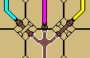
Please note, though, that composite colors can be mixes of primaries, other composites, or duplicated components. For example dark blue (C + M + K) can also be created other ways:
- (C + M) + K blue + black
- C + (M + K) cyan + dark magenta
- (C + K) + M dark cyan + magenta
- (C + K) + (M + K) dark cyan + dark magenta
- (C + M) + (C + K) blue + dark cyan
- (C + M) + (M + K) blue + dark magenta
As long as no additional colors are included, the output color is valid and appears the same.

